**SAFIULLAH KHAN (25K-0036)**

**BAI-1A**

**PF LAB#3 TASKS**

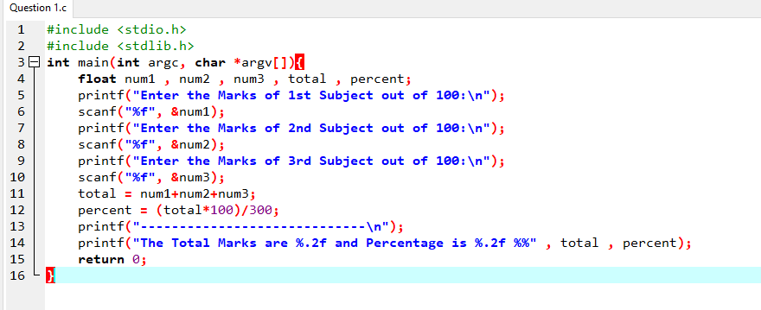Problem#1

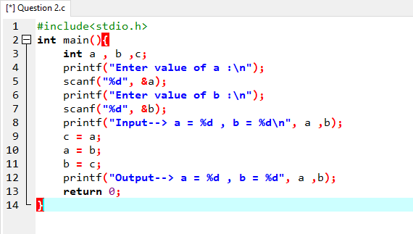Problem#2

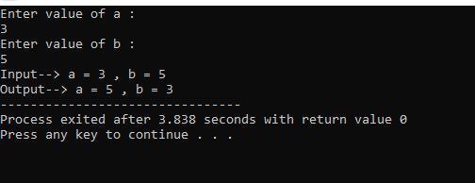

Problem#3

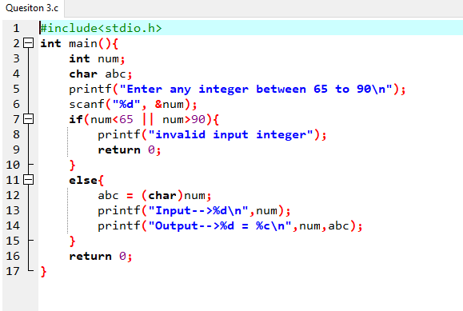

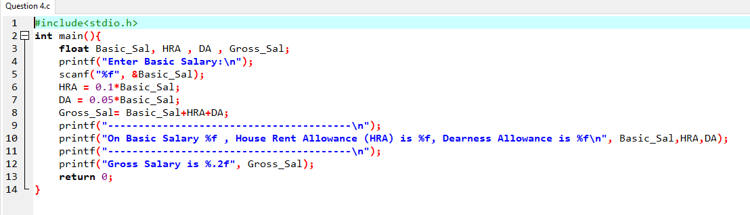Problem#4

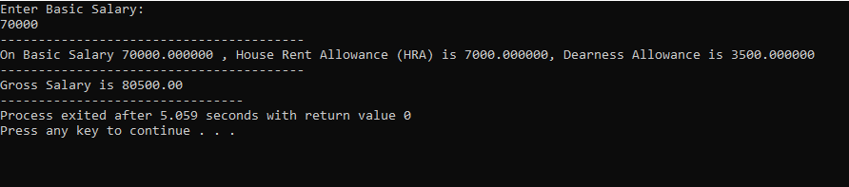

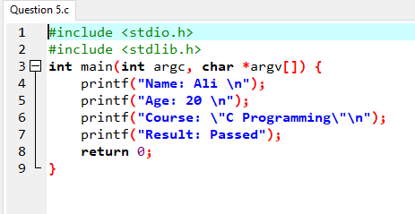Problem#5

